**Oracle Administration Services**

**CHANGE CREATION FOR STORAGE ALLOCATION**

Submitted to



**By**



CIS, Wipro Limited

Document Details

|  |  |
| --- | --- |
| Project Name | Innogy SE |
| Account | CIS |
| IT Component/Application Title | Change creation for Storage allocation |
| Current Version | 1.2 |
| List of Contributors | Sreya Puthukudy |
| Customer Contact Information |  |

Version History

(All revisions made to this document must be listed in chronological order. All revisions must be approved. Review and Approval can be done by an internal source or by the customer)

|  |  |  |  |  |  |
| --- | --- | --- | --- | --- | --- |
| Version | Date of Revision | Description | Author | Reviewed By | Approved By |
| 1.0 | 27-11-2017 | Initial Draft | Sreya Puthukudy | Jitenkumar Pansara | Mahesh Keshatwar |
| 1.1 | **30-11-2017** | **Document Completed** | **Sreya Puthukudy** | **Jitenkumar Pansara** | **Mahesh Keshatwar** |
| 1.2 | **30-12-2018** | **Updated the content** | **Sreya Puthukudy** | **Jitenkumar Pansara** | **Santosh Badiger** |

Document Distribution List

|  |  |  |
| --- | --- | --- |
| **S.No** | **Name and Company** | **Purpose** |
| **1** | RWEIT-ORACLEDBA | **This document is about the process of creation of change for storage allocation on Aix, Solaris, Windows server** |
| **2** |  |  |

**TABLE OF CONTENT**

1. Purpose 5

2. Scope 5

3. Steps to create change for Storage allocation 5

# Purpose

This document is prepared to understand the process of change creation for Storage allocation.|:dg&hx ja)Mz0

# Scope

This document is prepared for RWE GBS UK Wipro sustenance team and provides the steps to create change for storage allocation on AIX, Solaris and Windows server.

# Steps to create change for Storage Allocation:

**3.1** In Service Now, select “ Create new Change” option

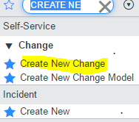

## A new change will be opened as shown below:

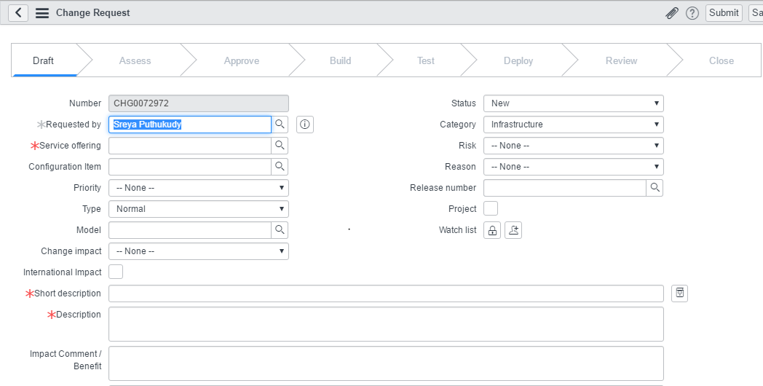

## If you are creating the template change, enter the MODEL ID. Model ID’s will differ according to the platform for which the change is to be created.

For example:

|  |  |  |
| --- | --- | --- |
| Allocate SAN To IBM / AIX Server - SCR/BAU | CHGMOD0001320 | AIX server |
| Allocate SAN To Solaris Server - SCR/BAU | CHGMOD0007519 | Solaris server |
| Allocate SAN To Windows Server - SCR/BAU | CHGMOD0004107 | Windows server |

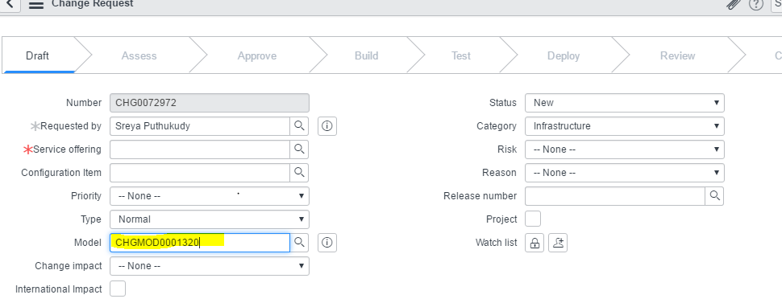

**3.4** Click on OK

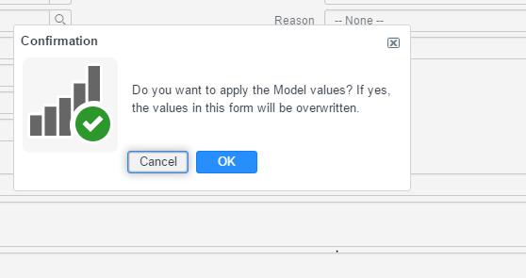



## After clicking on OK, few necessary details will be auto populated. Fill server name, Details of SAN increase, Reason, Service offering, Configuration Item, and Priority. Request for Total Space and LUN ID from the platform team and fill in those details in the required field.

## Note: Change task will be auto created .Don’t make any changes in change without approval from change manager in this case.

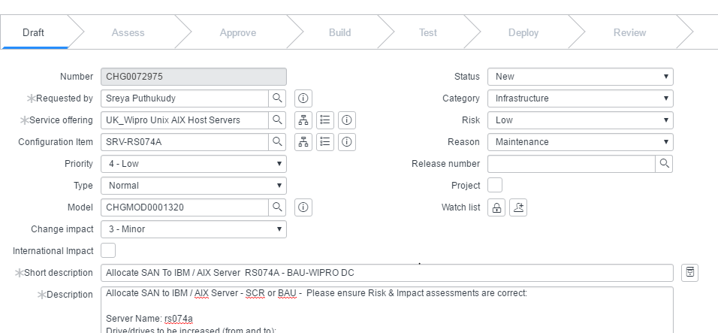

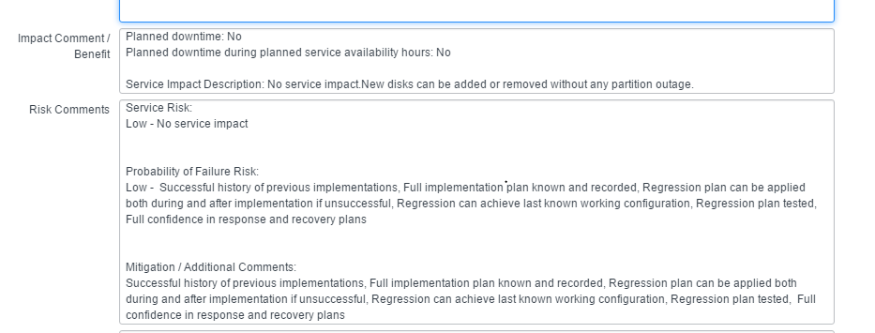

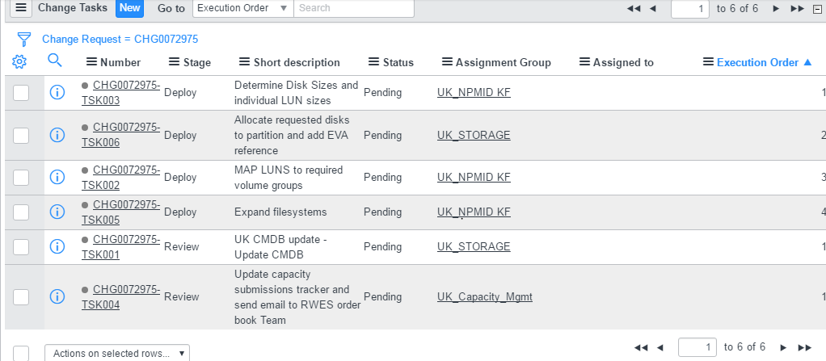

**3.6**  Provide file system details with the required space details:

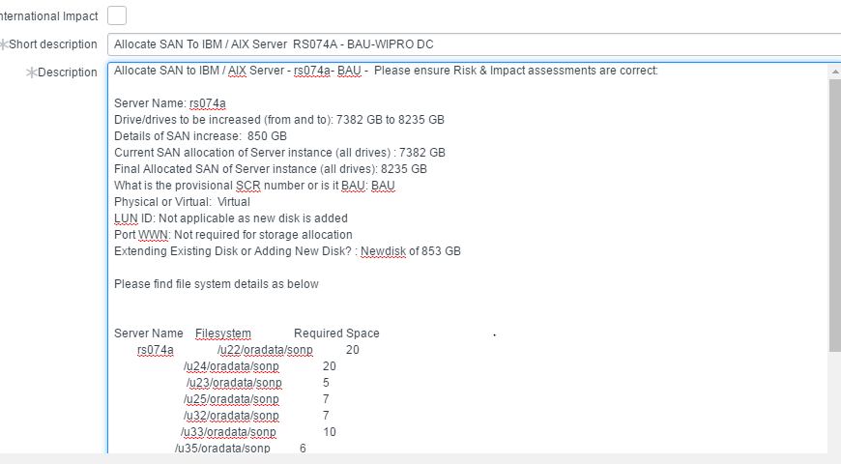

**3.7** Also provide the storage details in the Excel Sheet and attach the same in the change request.

|  |  |  |
| --- | --- | --- |
| STORAGE ALLOCATION REQUEST TEMPLATE | | |
| **BAU or SCR No.** |  | |
| **Change Number** | CHG00XXXXX | |
| **Storage required Date** |  | |
| **New Server / Existing server** |  | |
| **Physical / Virtual** |  | |
| **Server Name /Cluster Name/VIOS** |  | |
| **WWPNS** |  | |
| **Total Storage Request** |  | |
| **New Disk or LUN  expansion(Provide LDEV ID)** |  | |
| LDEV BREAK UP | | |
|  | **Number of Disks** | **Capacity** |
| **LDEV** |  |  |
| **C drive  /Root** |  |  |
| **D and E /Data** |  |  |
| **F and /Data** |  |  |

**3.8** Select the planned start date and Planned end date. There should be minimum 3 days window provided for storage allocation.

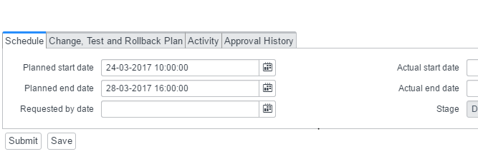

**3.9** Select the change ‘Affected Area’ and change Buisness Area as shown below:

**Affected Area:**

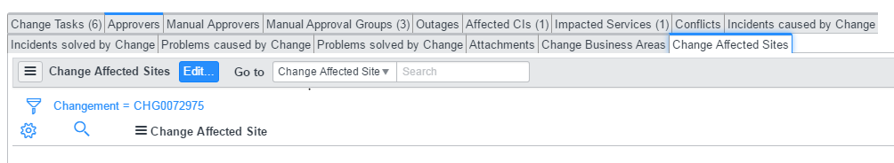

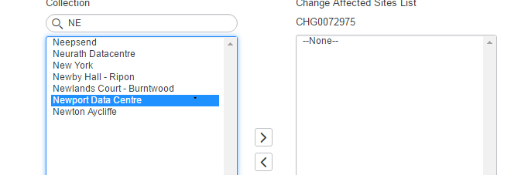

**Business Area**:

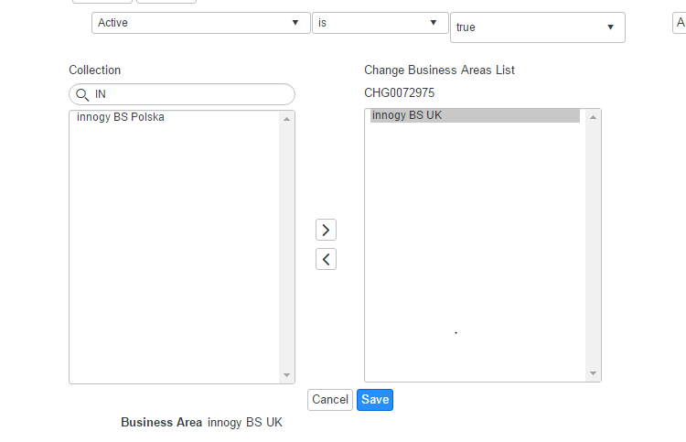

# Fill change plan, test plan and rollback plan.

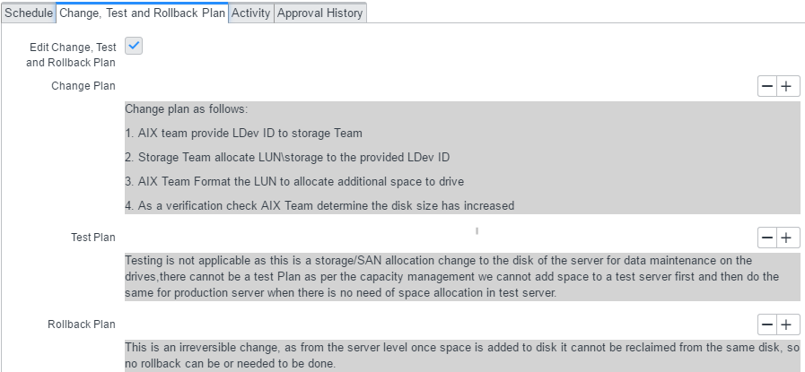

# Click on SUBMIT after peer review. Initiate a MAIL COMMUNICATION to the teams involved informing about the change.